**Bandit Level 1**

“The password for the next level is stored in a file called **readme** located in the home directory. Use this password to log into bandit1 using SSH. Whenever you find a password for a level, use SSH (on port 2220) to log into that level and continue the game.”

From level 0, I am now in the ssh session, I ran the command ls

And saw the readme file mentioned above

I then ran the command:

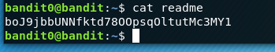

I copied the password boJ9jbbUNNfktd78OOpsqOltutMc3MY1

Hit exit and closed out of the SSH for banit0

I then entered:

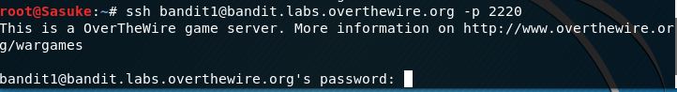

I then entered the password above and see if it works:

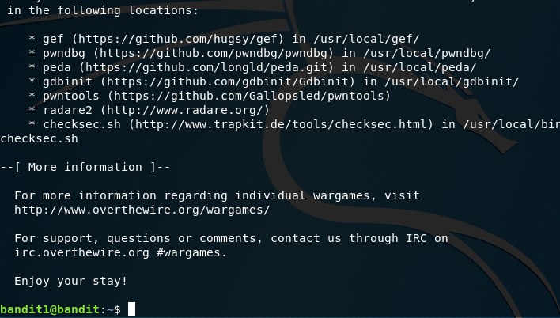

Success!